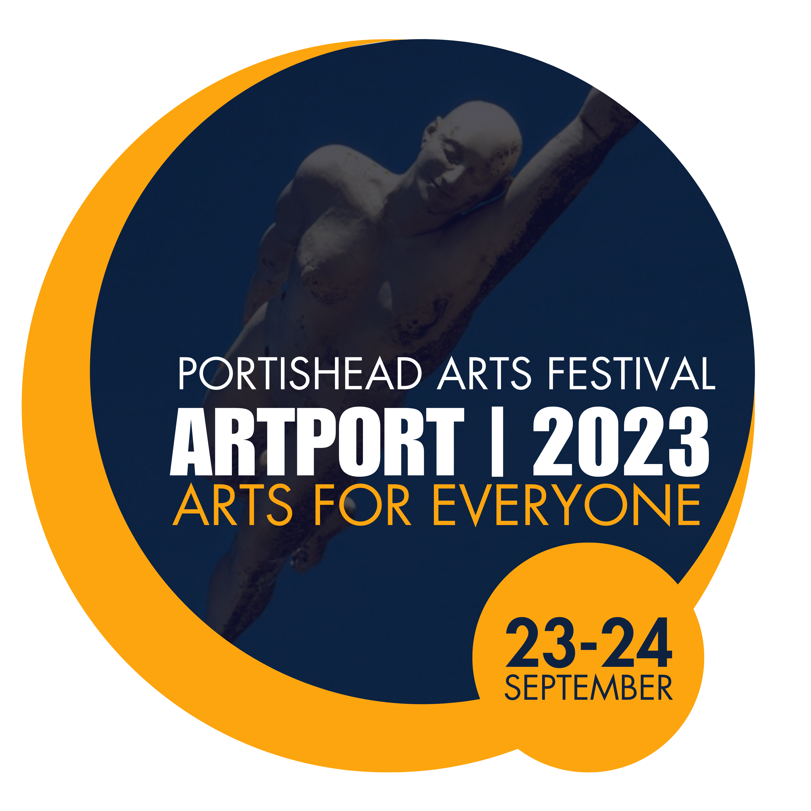

ARTPORT 2023 PHOTOGRAPHY COMPETITION ENTRY FORM

USE THIS FORM IF YOU ARE GOING TO PAY BY PAYPAL.

Deadline: before 5pm on Thursday 14th September.

Entry fee: £2.50 per photograph or £6.00 for an entry of 3 photographs.

Please complete this form and submit your photos before 5pm on Thursday 14th September.
The fee is £2.50 per photograph or £6.00 for an entry of 3 photographs.

On your PayPal Home page, press the SEND button and type in alan.harrison@bristol.ac.uk and then put your NAME and the reference PAFPHOTOCOMP in the “What’s this payment for” box.

Then send this completed form, together with your photographic entries by e-mail to: pafphotocomp@gmail.com

*Please ensure that you have read the rules and entry requirements on the ARTPORT 2023 website www.portisheadartsfestival.org/photography-competition

ARTPORT 2023 AMATEUR PHOTOGRAPHY COMPETITION ENTRY FORM

Family name…………………………………… First name………………………………..

Address……………………………………………………………………………………………………

………………………………………………………………………………………………………………….

………………………………………………………………………………………………………………….

Post code………………………

E-mail address……………………………………………………………………………………..

If under 18, please enter your date of birth………………………………..

Number of photographic files submitted by email …………………………………..

Entry fee £ …………

By submitting this form, you are declaring that you have read, understood and agree to abide by the rules of the ArtPort Photography competition, as set out on the Portishead Arts Festival website.

